EXPT NO: 1 | BUILDING AND TRAINING A SIMPLE ARTIFICIAL NEURAL NETWORK (ANN) FOR REGRESSION AND CLASSIFICATION
DATE: 20-07-2026

PRE-LAB QUESTIONS (PROVIDE BRIEF ANSWERS TO THE FOLLOWING QUESTIONS)

- What is an Artificial Neural Network (ANN)?
An Artificial Neural Network (ANN) is a machine learning model inspired by the human brain that learns patterns from data to make predictions or classifications.

- What are the functions of the input, hidden, and output layers in an ANN?
Input Layer: Receives the input data.
Hidden Layer: Processes the data and learns patterns using neurons and activation functions.
Output Layer: Produces the final prediction or result.

- Why is feature scaling important before training an ANN?
Feature scaling ensures all input features are on a similar scale, helping the model train faster, improve accuracy, and converge more efficiently.

- Differentiate between regression and classification problems with examples.
- Regression: Predicts continuous values. Example: Predicting house prices.
- Classification: Predicts categories or classes. Example: Classifying emails as spam or not spam.

- What is the role of the activation function in a neural network?
The activation function introduces non-linearity into a neural network, allowing it to learn and model complex patterns and relationships in data. Without an activation function, the network would behave like a simple linear model, regardless of how many layers it has. Common activation functions include ReLU, Sigmoid, and Tanh.

AIM
To understand the implementation of Artificial Neural Networks (ANN) using TensorFlow and evaluate their performance on regression and classification problems.

SOFTWARE REQUIREMENTS
- Python 3.x
- Google Colab / Jupyter Notebook
- TensorFlow 2.x
- NumPy
- Pandas
- Matplotlib
- Scikit-learn

LEARNING OBJECTIVES
After completing this experiment, students will be able to:
- Understand the architecture of an Artificial Neural Network.
- Build an ANN for regression problems.
- Build an ANN for classification problems.
- Train and evaluate neural network models.
- Compare different evaluation metrics used for regression and classification.

THEORY
An Artificial Neural Network (ANN) is a machine learning model inspired by the human brain. It consists of interconnected neurons organized into layers.
A simple ANN contains:
- Input Layer
- Hidden Layer(s)
- Output Layer
During training, the ANN learns by updating weights using Backpropagation and an optimization algorithm such as Adam Optimizer.

PART A – ANN FOR REGRESSION
DATASET: California Housing Dataset
SOURCE: Scikit-learn
DESCRIPTION
- Samples: 20,640
- Features: 8
- Target: Median House Value

FEATURES
Feature | Description
MedInc | Median Income
HouseAge | House Age
AveRooms | Average Rooms
AveBedrms | Average Bedrooms
Population | Population
AveOccup | Average Occupancy
Latitude | Latitude
Longitude | Longitude

ALGORITHM
- Import libraries.
- Load California Housing dataset.
- Split into training and testing sets.
- Standardize the features.
- Build ANN model.
- Compile the model.
- Train the model.
- Predict house prices.
- Evaluate using:
  - MSE
  - MAE
  - RMSE
CODE:
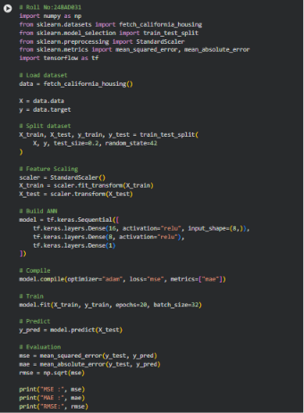
OUTPUT:
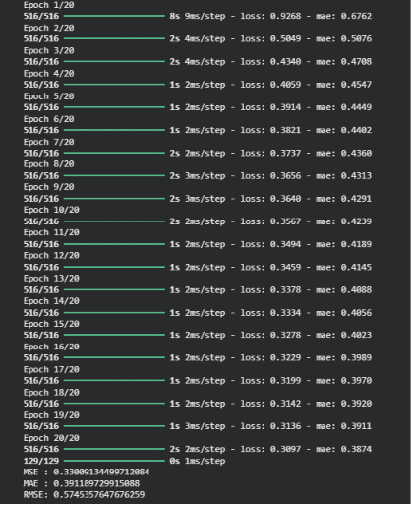

PART B – ANN FOR CLASSIFICATION
DATASET: Breast Cancer Wisconsin Dataset
SOURCE: Scikit-learn
DESCRIPTION
- Samples: 569
- Features: 30
- Classes:
  - Malignant
  - Benign

ALGORITHM
- Import libraries.
- Load Breast Cancer dataset.
- Split dataset.
- Standardize features.
- Design ANN.
- Compile model.
- Train model.
- Predict labels.
- Evaluate:
  - Accuracy
  - Precision
  - Recall
  - F1-score
  - Confusion Matrix

CODE:
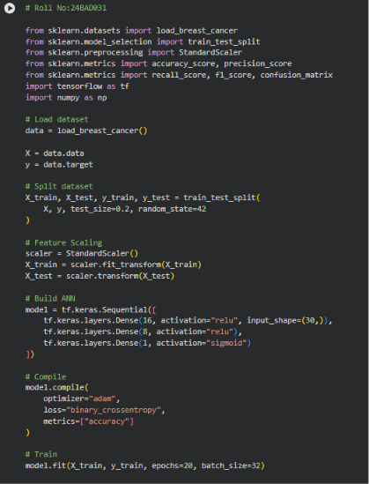
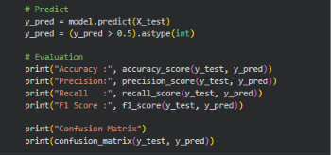

OUTPUT:
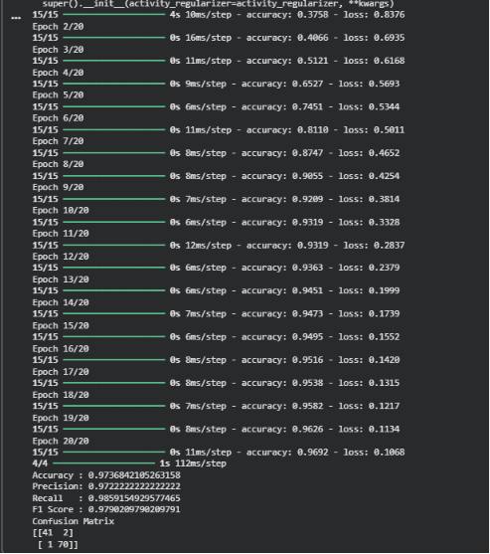

POST-LAB QUESTIONS (PROVIDE BRIEF ANSWERS TO THE FOLLOWING QUESTIONS)

- Why is the Adam optimizer commonly used in ANN training?
Adam is commonly used because it combines fast convergence, adaptive learning rates, and efficient optimization, making training faster and more stable.

- Compare Mean Squared Error (MSE) and Mean Absolute Error (MAE). Which metric is more sensitive to outliers?
MSE: Calculates the average of squared errors and gives more weight to large errors.
MAE: Calculates the average of absolute errors and treats all errors equally.
More sensitive to outliers: MSE.

- Why is the sigmoid activation function used in binary classification?
The sigmoid function outputs values between 0 and 1, making it suitable for representing probability of two classes.
- How does increasing the number of hidden layers affect the performance of an ANN?
More hidden layers help the ANN learn complex patterns, but too many layers can increase training time and may cause overfitting.

- Compare the evaluation metrics used for regression and classification tasks. Why are different metrics required for these problems?
Regression metrics: MSE, MAE, RMSE (measure prediction errors).
Classification metrics: Accuracy, Precision, Recall, F1-score (measure how well classes are predicted).
Different metrics are required because regression predicts continuous values, while classification predicts categories.

ASSESSMENT
Description | Max Marks | Marks Awarded
Pre Lab Exercise | 5
In Lab Exercise | 10
Post Lab Exercise | 5
Viva | 10
Total | 30
Faculty Signature

